Journals of the Asia Joint Conference on Computing Publishing

Please DO NOT insert author name and affiliation in the manuscript

ABSTRACT (between 1-2 pages)
Introduction and Background:
Material and Methods:
Results:
Conclusion:

Keywords: first term, second term, third term, fourth term, fifth term, sixth term

References
The preference format for AJCC is American Psychological Association 7th Edition (APA) style. As shown in the following examples.
More information you can look at the link https://www.cite.auckland.ac.nz/2.html

References
  - Journal Article
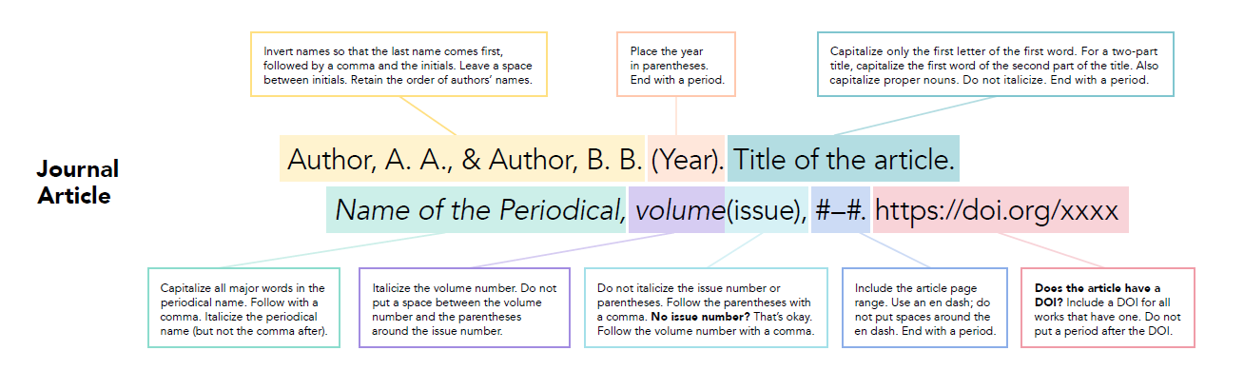Figure 2. APA journal article reference style.

  - Book
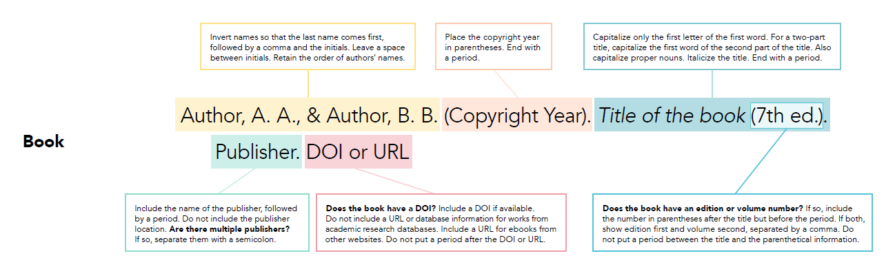
Figure 3. APA book reference style.

  - Book Chapter
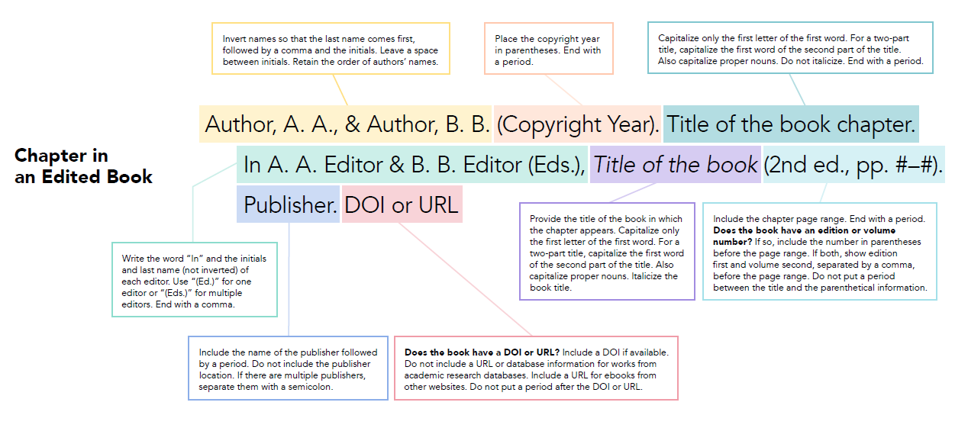
Figure 4. APA book chapter reference style.

  - Conference

Lim, S. P., & Haron, H. (2013). Performance comparison of Genetic Algorithm, Differential Evolution and Particle Swarm Optimization towards benchmark functions. 2013 IEEE Conference on Open Systems, 41–46.

References
Al-Kazemi, B. S., & Habib, S. J. (2006). Complexity Analysis of Problem-dimension Using PSO. Proceedings of the 7th WSEAS International Conference on Evolutionary Computing, 45–52.
Asadifar, S., & Kahani, M. (2017). Semantic association rule mining: A new approach for stock market prediction. Proceedings of the 2nd Conference on Swarm Intelligence and Evolutionary Computation, 106–111.
Drozdik, M., Aguirre, H., & Tanaka, K. (2013). Attempt to Reduce the Computational Complexity in Multi-objective Differential Evolution Algorithms. https://doi.org/10.1145/2463372.2463453
Gray, P., & Watson, H. J. (1998). Present and future directions in data warehousing. SIGMIS Database, 29(3), 83–90. https://doi.org/10.1145/313310.313345
Hansen, N., D Müller, S., & Koumoutsakos, P. (2003). Reducing the Time Complexity of the Derandomized Evolution Strategy with Covariance Matrix Adaptation (CMA-ES). Evolutionary Computation, 11, 1–18. https://doi.org/10.1162/106365603321828970
Krause, O., Arbonès, D., & Igel, C. (2016). CMA-ES with Optimal Covariance Update and Storage Complexity.
Lim, S. P., & Haron, H. (2013). Performance comparison of Genetic Algorithm, Differential Evolution and Particle Swarm Optimization towards benchmark functions. 2013 IEEE Conference on Open Systems, 41–46.
Nopiah, Z. M., Khairir, M. I., Abdullah, S., Baharin, M. N., & Arifin, A. (2010). Time Complexity Analysis of the Genetic Algorithm Clustering Method. Proceedings of the 9th WSEAS International Conference on Signal Processing, Robotics and Automation, 171–176. http://dl.acm.org/citation.cfm?id=1807817.1807849
Pan, J.-S., Snasel, V., Corchado, E. S., Abraham, A., & Wang, S.-L. (Eds.). (2014). Intelligent Data analysis and its Applications, Volume I: Proceeding of the First Euro-China Conference on Intelligent Data Analysis and Applications, June 13-15, 2014, Shenzhen, China. Springer International Publishing. https://www.springer.com/la/book/9783319077758
Szynkiewicz, P. (2018). A comparative study of PSO and CMA-ES algorithms on black-box optimization benchmarks. Journal of Telecommunications and Information Technology, 8(4), 1–13. https://doi.org/10.26636/jtit.2018.127418
Tshilidzi, M. (2009). Computational intelligence for missing data imputation, estimation, and management: Knowledge optimization techniques: knowledge optimization techniques. IGI Global.
Wang, K.-P., Huang, L., Zhou, C.-G., & Pang, W. (2003). Particle swarm optimization for traveling salesman problem. Proceedings of the 2003 International Conference on Machine Learning and Cybernetics (IEEE Cat. No.03EX693), 3, 1583-1585 Vol.3. https://doi.org/10.1109/ICMLC.2003.1259748

